1. INTRODUCTION
   1. Overview

In the scheme of NAAN MUTHAZHVAN, The project is about “BUILD AN EMPLOYEE TRAVEL APPROVAL APPLICATION FOR CORPORATES”. Here we create travel approval app for apply your travel approvals in a easy way. It allows administrators to design, build, use and modify travelling approval management processes within a highly responsive, web based interface.

* 1. Purpose

The purpose of the project is to booking travel reservations, tracking loyalty points, and browsing travel packages. A travel planning software package can be used by travel agencies, travel suppliers, and consumers. Travel applications provide you all helps that your travel needs, such as location details, ticket booking facility, facility to book accommodation, taxi, and explore local experiences.

1. **Problem Definition& DesignThinking**
   1. EmpathyMap

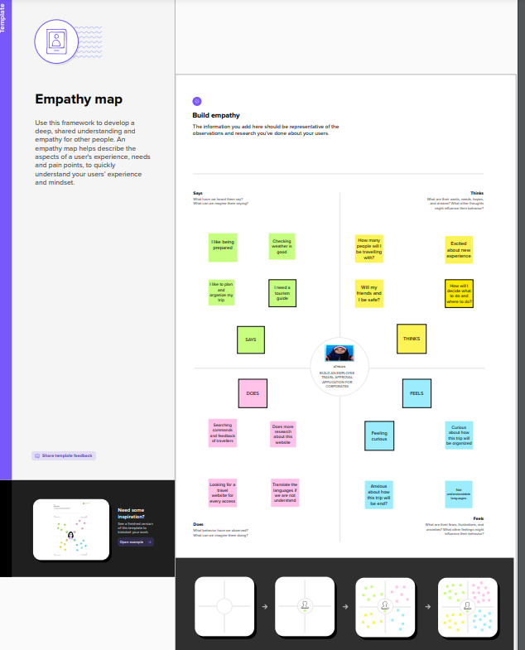

* 1. Ideation & Brainstorming Map

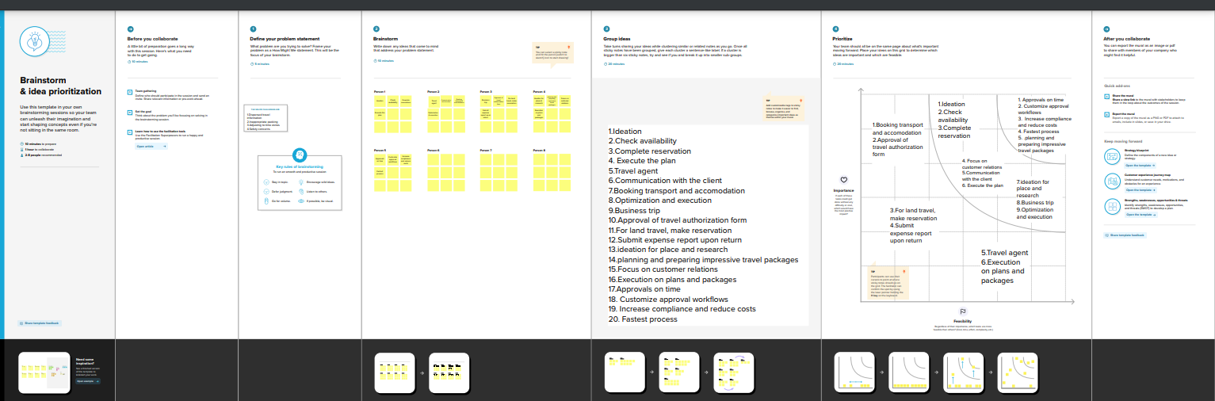

1. RESULT
   1. Data Model:

|  |  |
| --- | --- |
| **Object name** | **Fields in the Object** |
| obj1  1) STUDENT | |  |  | | --- | --- | | Field label | Data type | | Travel approval | Master Detail | | Amount | Currency | |
| obj2  2) TRAVEL APPROVAL | |  |  | | --- | --- | | Field label | Data type | | Department | Text | | Status | Picklist | |  |  | |

* 1. Activity & Screenshot

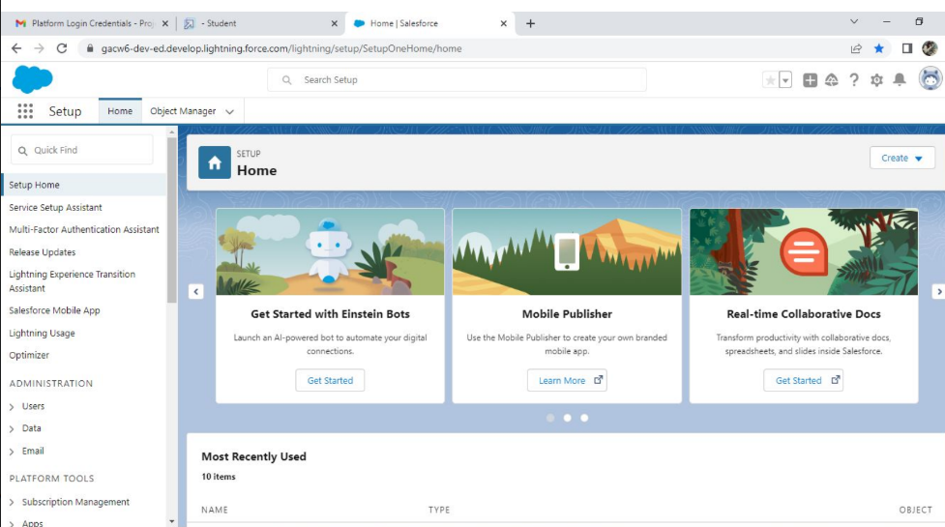

In My Project , this is my Home Page.

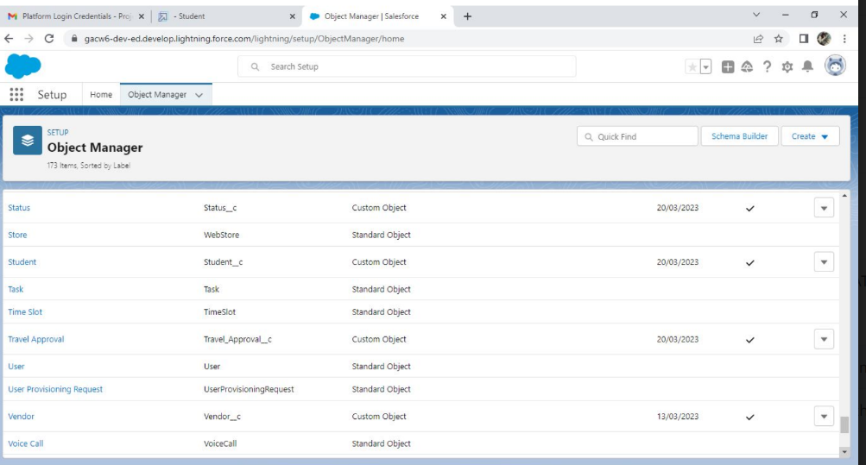

This is the page of object manager,

Here I create the custom objects by the instruction given in the project manual.

I create custom objects such as Departments, Travel Approval, Expense Item.

First I click the object manager and click create after that click custom objects and create the custom objects.

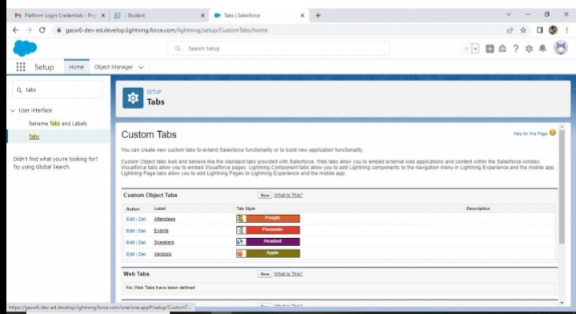

Next step is to create the custom tabs

At first we search the tab section in the quick find box.

click on tabs. Now the tab section opens.

Here click new . after that I create the custom tabs given in the project manual.

FINALLY, these are the custom tabs I have created in my project.

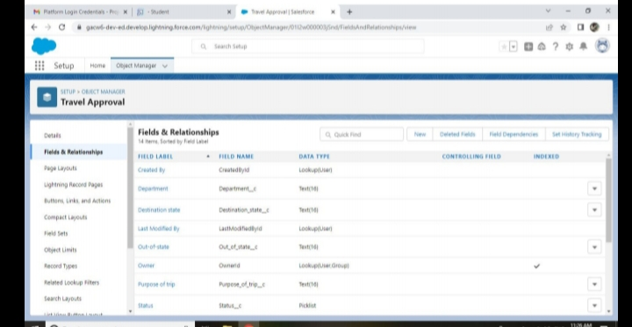

In the given project , The next step is to create Field and Relationship on the Travel Approval object

First I choose the object in the object manager

Then click Field and relationship , then I click new to create field and relationship.

Next I choose the data type given in the project manual.

Then click next until the save come, then click Save.

These is that page and these are the field and relationship that I have created in the project.

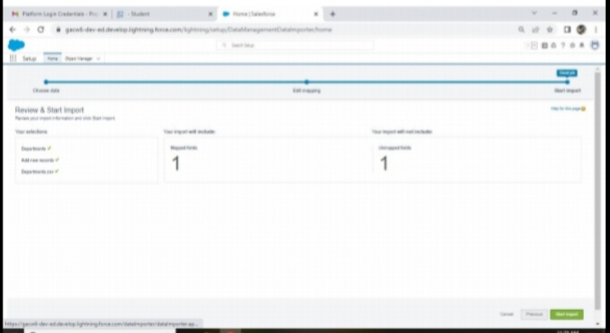

The next step of this project is DATA IMPORT WIZARD

First go to setup

Here I search the data import in the quick find box, click Data import Wizard.

Scroll down and click launch wizard.

After that I complete the following steps by the instruction given in the project manual

The last step is to click start import to complete this milestone.

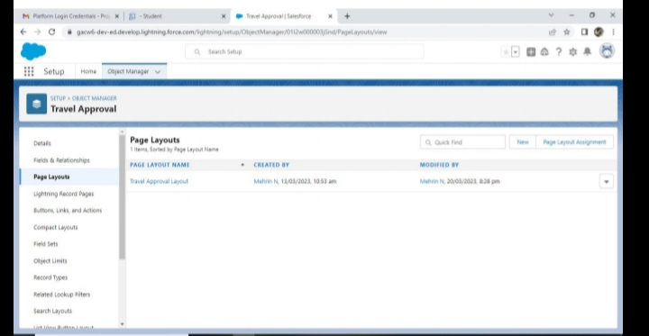

Next step of the project is to create page layouts.

First I choose the object in the object manager

Next click on page layouts , then click new.

Next give the name to your layout and then save it.

Here I create the travel approval layout as the page layout

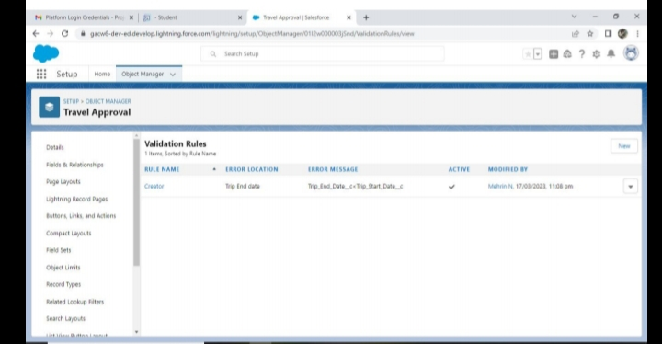

Next step of the project is to create the Validation rules in tha project given in the project manual.

First I choose the object in the object manager

Next click new after that give a rule name , error location , error message then save it.

This is the validation rule page that I created.

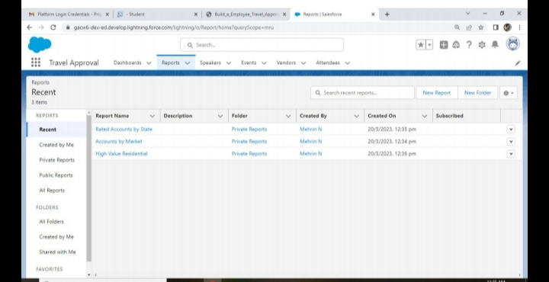

Next step is to create reports

Click applauncher for search reports.

Click new report and follow the instruction as per in the manual.

This is the report page of my project. Here I create three reports .

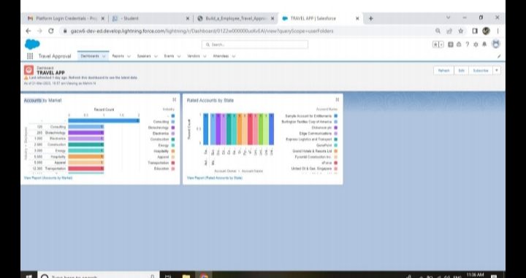

The final step of the project is to create the Dashboards.

Click on dashboard tab and click the (+) component to create new dashboard.

Next following the step to create the dashboard.

My dashboard name is Travel App and this is the Dashboard page.

1. Trailhead Profile Public URL

**Team Lead-** [**https://trailblazer.me/id/mehrn5**](https://trailblazer.me/id/mehrn5)

**Team Member 1 -** [**https://trailblazer.me/id/affra2**](https://trailblazer.me/id/affra2)

**Team Member 2 -** [**https://trailblazer.me/id/almor14**](https://trailblazer.me/id/almor14)

**Team Member 3 -** [**https://trailblazer.me/id/arthika**](https://trailblazer.me/id/arthika)

**Team Member 4 -** [**https://trailblazer.me/id/divyalakshmip**](https://trailblazer.me/id/divyalakshmip)

1. **ADVANTAGES & DISADVANTAGE**

**Advantage :-**

**Simplifies booking, Enhances travel personalization.**

**Enables direct and indirect travel cost savings.**

**Maximizes travelers safety, Ensures better travel policy Compliance.**

**Provides 24/7 support, grows with your company.**

**Disadvantages :-**

**Assuming always on data connection and Assuming high speed network access.**

1. APPLICATIONS

Nowadays this is the needed thing for the fastest going world.

We can use this TRAVEL APP everywhere. There are lots of benefits in it.

First we have to launch the app in the online platform for everyone to use.

1. CONCLUSION

It was a wonderful learning experience for me while working on this project . This project tooks me to know about travel app and travellers and gave me a real insight of working software. I enjoyed every part of this project and this is a great opportunity for me from NAAN MUTHAZHVAN.

1. FUTURE SCOPE

The future scope of the project is everyone will get an travel approval in an easy way and spent low amount for their travel.

Hope this scheme provides lots of job opportunities.

Thank you.